Results of Community Council RailwayReturn to Newtown St Boswells Survey
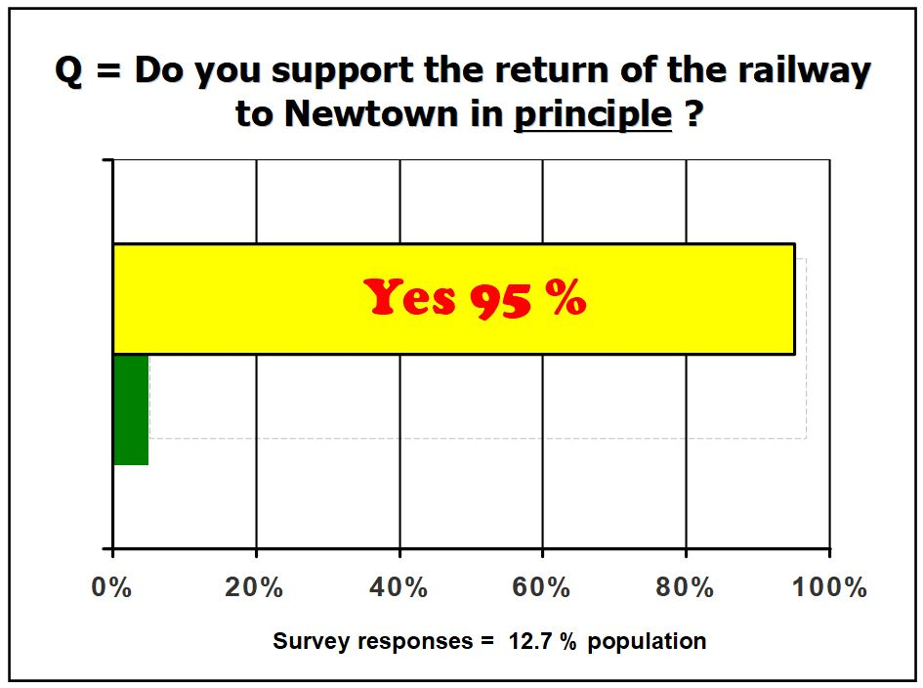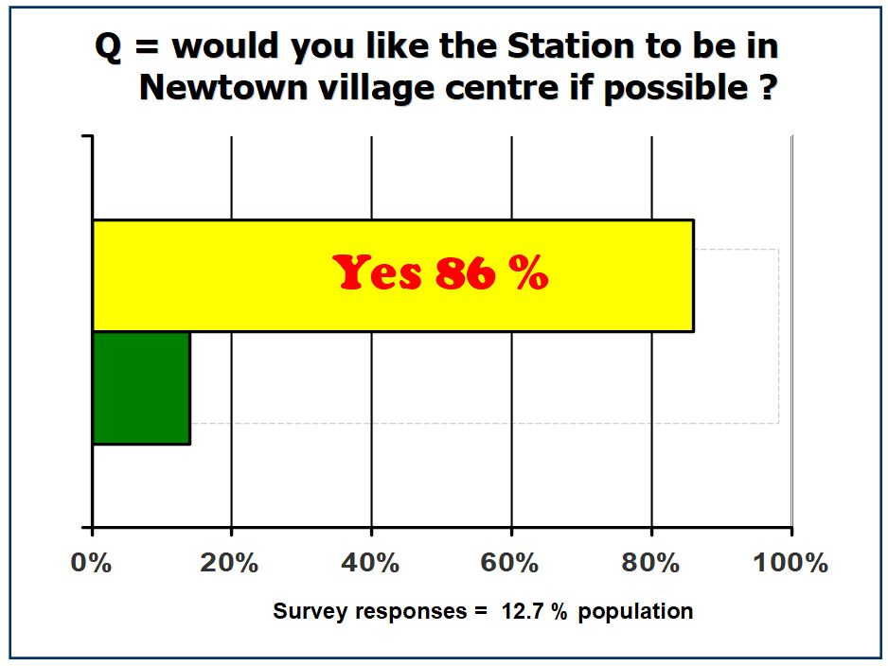

September 2018 Page 1 of 3

Comments collected from railway survey – September 2018

- Should never have been closed in the first place! Used to love getting the train home from the dancing on a Saturday night. Buses at moment not great for link.

- The community council should support the return of the railway to Carlisle

- Newtown is growing and the railway with station would be a big benefit !

- I think it would bring another much needed form of public transport and would be great for the village.

- Should go all the way to Carlisle.

- With all the additional houses planned it makes sense - jobs will need to be in Edinburgh. I use the railway 3-4 times a week.

- There must be several proposed routes and many possible station locations to be as sympathetic and practical as possible to the modern day landscape at Newtown. Very interested to see plans when they become available.

- Would be better via A7 road

- It would be great to have the railway back in Newtown as would be used by all

- The line should never have been removed

- Council HQ is based at Newtown, makes sense

- Would provide better transport links

- It would really benefit the people living here and the villages nearby.

- I feel this would assist the community with better links for public transportation and bring in possible trade

- It should be placed somewhere with plenty parking.

- Having seen the positive impact from the Borders railway on our area, extending the line south can only be positive in my view!!

- Great idea and would help local businesses and reduce social/rural isolation

- Onto Carlisle main line also

- it would be a huge positive to head south without having to head north first

- Would be great for the village and a huge economic boost.

- Newtown is a wonderful village and needs a huge amount of renovation. A lot of business and trade to current business's would hopefully benefit from the railway being brought back

- Use. The present line all the times quicker and better then buses by far

- Would rather the station was on the edge of the village so the dynamic would stay the same but would aid the flow of traffic etc. The village would need a lot of regeneration if the station was in the centre

- Anything that reduces traffic on the roads is a welcome move!!! Train travel is more stress free than car transport!!!

- Something's need to be done to bring life back into the village

- I m happy to walk to the station if it was close to Newtown and i do feel strongly about keeping the buildings and the heritage feel of the village

