Dryburgh Riverside Gate Closure - Public Petition

- The pedestrian gate has been used by local people for well over 30 years who have been given no plausible reason for it’s closure and wish to continue to use the gate.
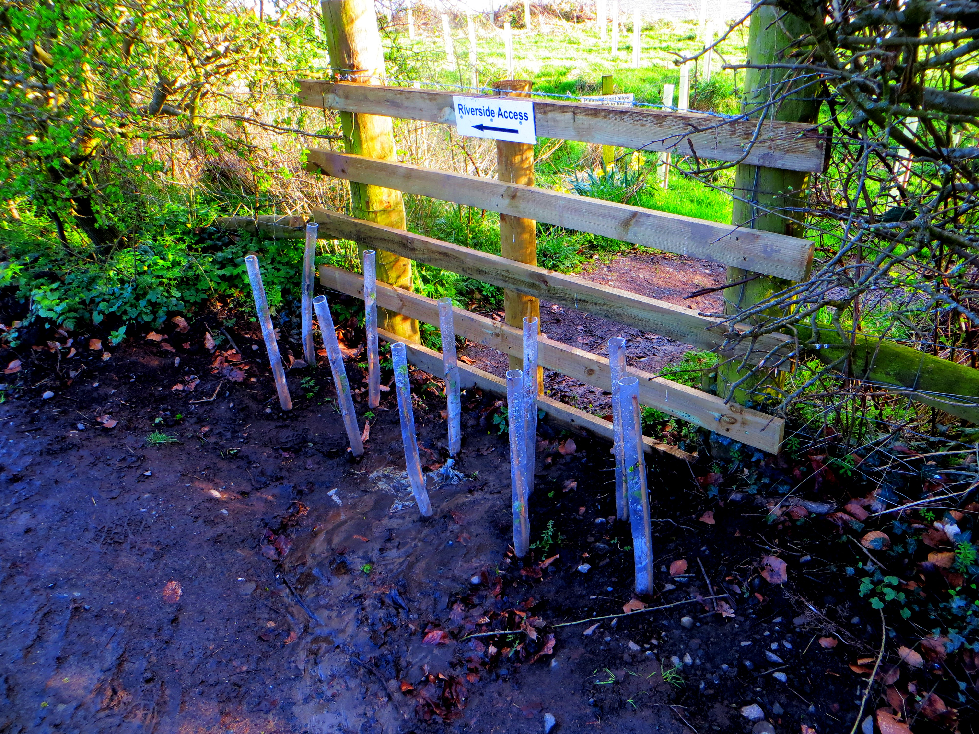
- The reason given for the gate closure was that it created a safety hazard when using the gate on to the road. However SBC is willing to reinstate the gate meeting all safety requirements at no charge to the landowner. Alternatively local people and SBC agree that it may be better positioned nearer the suspension bridge.

- Many walkers who wish to walk along the Dryburgh river bank park their cars on the Newtown St Boswells side of the suspension bridge, cross over the bridge and the gate has always been a convenient way to access the river bank.

- Blocking the gate interferes and lengthens a popular circular walk along the river bank to Monksford ford and back using the right of way across the fields. Walkers will be forced to use narrow road to the Stirling cottages either at the beginning or end of the walk.

- Blocking the gate has forced walkers to use the narrow road along to the Stirling cottages in order to access the river bank and use an existing gate to access river bank. For some reason the existing gate has been replaced with a new gate ?

- New dwellings created from the adjacent Steading and Farm house conversions will create up to 16 residents cars and possibly visitors regularly using the narrow road. Also the closure of the farm has resulted in the need to bring in farm tractors and equipment back and forwards along the narrow road in question.

- This together with the fishing traffic will change the nature of the road from that of a quiet narrow country lane with an occasional car to that of a well used road and will become a safety hazard for pedestrians. Before the gate in question was blocked off the river side path gave a safe off-road route between the Temple and the Stirling Cottages.

- Visitors to the Three Muses Temple from the Wallace statue, from the car park on the main road, from the Dryburgh Hotel and walkers using the Three Abbey’s walk will be forced to use the narrow road if the gate remains blocked at the Temple.

Reinstating the gate would give back public access to the river bank in a way used for many years and also improve pedestrian safety between Stirling Cottages and the Three Muses statue. Local people petition SBC and landowner to reinstate the gate.

NB. – The Planning Approval for the new fishing hut, up stream from the suspension bridge, had a ‘condition’ confirming the public had a right of access along the river bank. Therefore despite the some 500 trees recently planted on the river bank, the gate in question blocked and an additional metal gate on the river side path the path remains open for enjoyment by both fisherman and walkers.

